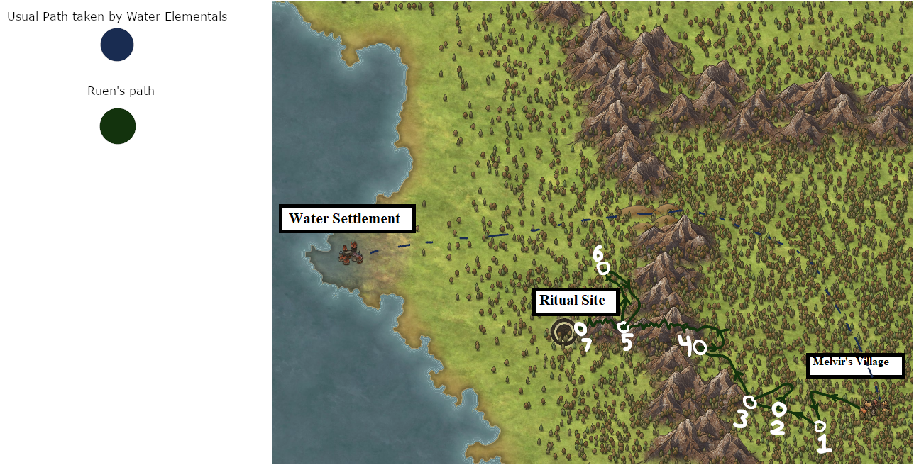

At the start of Swishing Gust’s story, he is around Creaking Rumble’s Village. Once Creaking Rumble dies and the corrupted Elementals flee the village, they are apprehended very nearby. The Water Elementals take them west, but Swishing Gust breaks them out.

0. Swishing Gust is caged near Hissing Rush and Whispering Crush. The two speak to each other quietly when the Water Elementals rest. Bubbling Splash is heard making a racket, demanding to be released as he has been cured of his corruption. Snapping Thump is seen briefly, quiet and unmoving. Rustling Snip is not seen. Hissing Rush tries to get Swishing Gust’s attention, but Swishing Gust just stares blankly. Hissing Rush and Whispering Crush agree there’s something up with him. Swishing Gust tries to shake the bars of his cage and attracts the attention of a Water Elemental keeping watch. He can’t understand what they say to him, but does pick up their name: Jun. He repeats it over and over, trying to form the word correctly. Doing so activates the stone’s power inside him, and his focus on the word turns the power into a spell. This inadvertently empowers and drives berserk some corrupted Elementals as their plantlife grows wildly. While the Water Elementals battle the berserk corrupted Elementals, Swishing Gust and a few other corrupted Elementals escape.

1. Swishing Gust and those corrupted Elementals that did not go berserk from Swishing Gust’s spell stop running and begin to talk.
   1. Hissing Rush clashes with Bubbling Splash and Snapping Thump, the latter duo wishing to be rid of corruption, while the former doesn’t mind the corruption, and just wishes for revenge upon the Water tribe. Bubbling Splash is especially struck by Hissing Rush’s anti-Water tribe goals, as he sees himself as a temporarily embarrassed Water Elemental. Rustling Snip joins in and fights against Bubbling Splash’s clear hatred of nature corruption. Whispering Crush approaches Swishing Gust and asks what they should do, and Swishing Gust is able to utter a sound. Everyone looks at him, and Rustling Snip begins examining the stoic Elemental.
   2. Rustling Snip proclaims that Swishing Gust should lead them, as he was the one that broke them out in the first place. Clearly he has some sort of power they don’t. The others agree, and look to Swishing Gust.
   3. Swishing Gust looks back, and tilts his head at Hissing Rush. After a pause, Hissing Rush says her name, and gestures to herself. Swishing Gust repeats it, then looks at Whispering Crush. This repeats for each individual. Swishing Gust looks down and quietly begins chanting the names. Hissing Rush touches his head while Whispering Crush grabs an arm, and they tell him to stop. Swishing Gust looks confused, and his eyes unfocus.
   4. Vacant, Swishing Gust motions west. After a pause, Swishing Gust begins walking that way, and one by one the others follow.
2. Differences in opinion begin to drive a wedge between the group. Hissing Rush, Whispering Crush, and Rustling Snip wish to embrace their corruption, or at least deal with it for the time being while completing other tasks. Bubbling Splash and Snapping Thump are decidedly against keeping their corruption, and believe they should beseech the Water tribe to cure them. Hissing Rush is adamant the ‘cure’ is death, while Whispering Crush is quiet and somewhat understanding and Rustling Snip is incredulous.
   1. This culminates in the group splitting. Hissing Rush, Whispering Crush, and Rustling Snip stay with Swishing Gust as he single-mindedly walks west. Bubbling Splash and Snapping Thump travel north, hoping to find the path the Water Elementals usually take to get to Creaking Rumble’s village.
   2. Soon after, a massive storm begins brewing. Massive herds of Wind and Lightning Elementals race across the sky, blowing clouds at breakneck speeds and striking the ground with electricity. Swishing Gust’s group takes refuge in a cave at the base of the mountain range, and soon Bubbling Splash and Snapping Thump arrive there too. They’re pursued by madly gleeful Wind and Lightning Elementals, and Swishing Gust’s group helps fend them off.
3. While the group weathers the storm in the small cave, they’re forced to work out their issues somewhat.
   1. Bubbling Splash has learned how to speak somewhat in a language the corrupted Earth Elementals can understand from Snapping Thump.
   2. Hissing Rush breaks an awkward silence by asking Bubbling Splash about his past. Bubbling Splash regales about single handedly chopping down a forest for the Water tribe, but finding algae growing on him soon after. He was then sent to Creaking Rumble’s village, where the algae bloom died off. He was then left with tree resin stuck in his form, and no plantlife could take hold. Bubbling Splash quietly, sadly, notes that he tried, before looking up and quickly asking Hissing Rush to share her past.
   3. Hissing Rush shares her past as well, and the similarities of being betrayed by the Water tribe.
   4. Rustling Snip interrupts the following silence with evangelization of corruption. How it was a gift unto him, that he went willingly from the Earth tribe and purposely disfigured his body, disturbing the compacted mud into dirt for more flowers to gain hold.
   5. Whispering Crush brings up that it does seem like they can’t fit into either tribe. Swishing Gust turns his head at Whispering Crush’s quiet observation that they should form their own tribe.
   6. Snapping Thump rudely interjects that corruption is known to kill, if it progresses too far. Whispering Crush shuts down at this, afraid of conflict as well as unsure how to deal with that fact.
   7. Another silence. This time interrupted by Swishing Gust. He slowly struggles out each of his companions’ names. A pause. Swishing Gust pronounces the word for “tribe” surprisingly well. The storm has begun to clear, and Swishing Gust walks outside and begins heading north. The others follow, a bit shocked.
4. The group heads north along the mountain range, hoping to find a path to sneak through.
   1. They happen upon a Water tribe outpost, and have to make an escape.
   2. Some fighting occurs. Not sure if any Water Elementals are killed. If they are, Hissing Rush probably would do it. Bubbling Splash would be pissed off, while Whispering Crush would be terrified. Rustling Snip would see it as necessary, and Snapping Thump would be exasperated.
   3. Bubbling Splash attempts to communicate with them, but they still see him as a corrupted Elemental. This deeply disturbs Bubbling Splash, and he quietly begins re-examining his views on corruption.
5. After adding some distance between the pursuing Water Elementals, Swishing Gust’s company launches into the mountains. They trek across them as swiftly as they can. As they’re coming down the other side, during a pitch black night two Water Elementals appear and attack the group, fleeing with a captured Swishing Gust.
   1. The group bickers as to what to do next. Hissing Rush insists that they go after him, but Bubbling Splash reminds her another Water tribe outpost is just north, so they’ll surely have backup. In fact, the Water forces may head south towards them soon, so they should continue on.
   2. Hissing Rush, Whispering Crush, and Rustling Snip assert that Swishing Gust is a special corrupted Elemental, and that he may be able to heal them at the ritual site.
   3. Bubbling Splash gives in and heads north under cover of darkness, the rest staying behind in hiding.
6. Bubbling Splash is able to somewhat pass as a Water Elemental guard, staying just in the corners of other Water Elementals’ vision.
   1. He locates Swishing Gust, but is approached by a guard. In the dim light, Bubbling Splash’s honey-brown color is difficult to view, and the guard questions Bubbling Splash, unsure of who he is.
   2. Bubbling Splash takes a moment to weigh his chances. He could reveal that he is a cured corrupted Elemental, and show that plantlife cannot spread on him, and be welcomed back into Water tribe society, possibly. But that could easily go south, and he could be captured at best and killed at worst. On the other hand, he could make a hasty escape with Swishing Gust.
   3. As Bubbling Splash stammers, trying to decide, Swishing Gust begins shaking the bars. Bubbling Splash turns his attention to Swishing Gust, and begins scolding him. He turns back to the guard and explains he was trying to extract information from this prisoner, and requests that he be left aWhispering Crushe to focus on that.
   4. The guard huffs and goes back to patrolling.
   5. Once aWhispering Crushe, Bubbling Splash looks at Swishing Gust, who stares blankly back. Bubbling Splash looks around one more time, then unlocks Swishing Gust’s cage, whispering his thanks.
   6. Bubbling Splash carries Swishing Gust away from the camp, back south to the corrupted Elemental group.
7. The group reaches a cliff overlooking a massive stone circle populated with hundreds of corrupted Elementals. Water Elementals surround the pit, and channel energy through their bodies towards a nexus underneath the cliff. The group pauses, and weighs their actions.
   1. Bubbling Splash insists they join the ritual, as it’s obviously built to try and cure the Elementals. Hissing Rush refuses outright, saying it’s most likely to cleanse them by killing them. Snapping Thump insists they take the chance, while Rustling Snip is unusually quiet and contemplative. Whispering Crush is quiet, sitting near Swishing Gust, who stares blankly.
   2. Hissing Rush approaches Swishing Gust and beseeches him to use his power on the corrupted Elementals below. They could end the ritual and save all of the Elementals’ lives. Swishing Gust slowly gets up and begins walking towards the cliff. Bubbling Splash fumes while Snapping Thump looks on. Swishing Gust stands atop the cliff and begins raising his arms, a muttering chant forming. A yell is heard as Water Elementals realize corrupted Elementals are on the cliff. They begin running towards the group.
   3. Bubbling Splash panics, and as the Water Elementals near, he rushes up behind Swishing Gust and stabs him through with his arm. He hopes to be seen killing a corrupted Elemental, and possibly save himself from the Water Elementals’ ire.
   4. Swishing Gust falls, the stone shattering inside him. Hissing Rush, Whispering Crush, and Rustling Snip dive after Swishing Gust as Snapping Thump flees and Bubbling Splash hails the Water Elementals.